آزمونهای تخصصی پوشش های خطوط لولههای مورد استفاده در صنایع نفت، گاز و آب
Epoxy Powder
ISO 21809-1 | Density |  |  | 1
ISO 21809-1 | Gel time @ 200 °C |  |  | 2
ISO 21809-2 | Particle size |  |  | 3
ISO 21809-1 | Moisture content, max % |  |  | 4
ISO 21809-1 | Glass transition temperature  T_{g}1  T_{g}2  ∆H |  |  | 5
ISO 21809-2 | Cathodic Disbonding 28 Days 65 °C, 1.5 V |  |  | 6
ISO 21809-2 | 3.0° ppd flexibility, at -30 °C |  |  | 7
ISO 21809-2 | Hot Water Adhesion 24 hr At 75±3 °C |  |  | 8
Adhesive
ISO 1183 | Density @ 23±2 °C gr/cm³ |  |  | 9
ISO 3146 | Melting index (2.16 kg/190 °C) gr/10 min  (Granule) |  |  | 10
ASTM D3418 | Melting Point (DSC), min °C |  |  | 11
ISO 527-1 and -2 or  ISO 527-1 and -3 or  ASTM D638 | Elongation at break % min |  |  | 12
ISO 527-1 and -2 or  ISO 527-1 and -3 or  ASTM D638 | Tensile strength @ Yield 23±2 °C, min MPa |  |  | 13
ISO 15512 | Water content, max % |  |  | 14
ISO 306 or ASTM D1525 | VICAT Softening A/50 (9.8 N) min °C |  |  | 15
Poly Ethylene
ISO 1183 (all parts) or  ASTM D792 or  ASTM D1505 | Density @ 23±2 °C gr/cm³ |  |  | 16
ISO 3146 or  ISO 11357-1 and -3 or  ASTM D3418 | Melting index (2.16 kg/190 °C) gr/10 min  (Granule) |  |  | 17
ISO 3146 or  ISO 11357-1 and -3 or  ASTM D3418 | Melting index (2.16 kg/190 °C) gr/10 min, (Extruded) |  |  | 18
ISO 527-1 and -2 or  ISO 527-1 and -3 or  ASTM D638 | Elongation at break %, min |  |  | 19
ISO 1133 | Melting point (DSC), min , °C |  |  | 20
ISO 527-1 and -2 or  ISO 527-1 and -3 or  ASTM D638 | Tensile strength, at break 23±2 °C, min, MPa |  |  | 21
ISO 527-1 and -2 or  ISO 527-1 and -3 or  ASTM D638 | Yield strength, at 23±2 °C, min, MPa |  |  | 22
ISO 868 | Hardness Shore D min |  |  | 23
ISO 15512 | Water content , max % |  |  | 24
ISO 11357 | O.I.T @ 210 °C minute |  |  | 25
ISO 306 or ASTM D1525 | VICAT Softening temperature A/50(9.8 N ) min |  |  | 26
ASTM D 1603 | Carbon Black Content % |  |  | 27
ISO 18553 | Carbon black dispersion |  |  | 28
 | Stress Cracking resistance  (50 °C MEK , 1000 hr) |  |  | 29
ISO 21809 | Thermal Aging % |  |  | 30
Coal Tar Enamel
BS 4147-Appendix B | Filler content by ignition, % by mass |  |  | 31
BA 2000 | Softening point (Ring and Ball), °C |  |  | 32
BS 4147-Appendix D | Penetration  @ 25 °C, 0,1 mm  @ 45 °C, 0,1 mm |  |  | 33
BS 4147-Appendix C | Density (gr/cm³) |  |  | 34
BS 4147 | Sag, maximum mm 80 °C 24 h |  |  | 35
BS 4147 | @ 30 °C | Peel initial and delayed, maximum mm |  | 36
 | @ 40 °C
 | @ 50 °C
 | 60 °C @
ASTM G 8 | Cathodic disbonding, disbonded radius  after 28 d, maximum, mm |  |  | 37
Bitumen & Modified Bitumen Enamel
BS 4147-Appendix B | Filler content by ignition, % by mass |  |  | 38
BS 2000 | Softening point (ring and ball), °C |  |  | 39
BS 4147-Appendix D | Penetration at 25 °C, 0,1 mm |  |  | 40
BS 4147-Appendix C | Density (gr/cm³) |  |  | 41
BS 4689 | Flash point (Cleveland open cup), minimum °C |  |  | 42
BS 4147-Appendix E | Sag, maximum mm |  |  | 43
BS 4147-Appendix G | Impact disbonded— Area, maximum mm² |  |  | 44
BS 4147-Appendix H | @ 30 °C |  | Peel initial and  delayed, maximum  mm | 45
 | @ 40 °C
 | @ 50 °C
 | 60 °C @
BS 4147-Appendix F | Bend at 0 °C, minimum, mm |  |  | 46
ASTM G 8 | Cathodic disbonding, disbonded radius  after 28 d, maximum, mm |  |  | 47
Outer Wrap
ASTM D 146 | Thickness (mm) |  |  | 48
ASTM D 146 | Mass per area, minimum |  |  | 49
ASTM D 882 | Tensile strength, minimum  Longitudinal (N/ 50 mm)  Transverse (N/50 mm) |  |  | 50
AWWA C 203 | Weight Loss on Heating (% by weight) |  |  | 51
ASTM D 737 | Porosity |  |  | 52
ASTM D 146 | Pliability |  |  | 53
 | Resistance to water  Longitudinal (N/ 50 mm)  Transverse (N/50 mm) |  |  | 54
 | Appearance |  |  | 55
Inner Wrap
ASTM D 146 | Thickness (mm) |  |  | 56
ASTM D 146 | Mass per area, minimum |  |  | 57
ASTM D 882 | Tensile strength, minimum  Longitudinal (N/50 mm)  Transverse (N/50 mm) |  |  | 58
EN 10300 | Resistance to Oil  Longitudinal (N/ 50 mm)  Transverse (N/50 mm) |  |  | 59
ASTM D 146 | Pliability |  |  | 60
EN 10300 | Binder Content max |  |  | 61
EN 10300 | Appearance |  |  | 62
Primer
EN ISO 2431 | Flow time (Flow Cup No 4 @ 23 °C), seconds |  |  | 63
EN ISO 13736 | Flash point (Abel closed cup), minimum °C |  |  | 64
EN 10300 | Volatile matter, maximum % loss by mass |  |  | 65
EN 10300 | Ash Content(mass) Max%  Loss by mass |  |  | 66
Heat Shrinkable Sleeve Field Joint
ASTM D 1000 | Backing thickness (as supplied) , min |  |  | 67
ASTM D 1000 | Adhesive thickness (as supplied), min |  |  | 68
ASTM D 1000 | Total thickness (as Supplied) , min |  |  | 69
ASTM D 2240 | Hardness @ 23 °C , Shore D min |  |  | 70
EN 12068 | Impact resistance at 23 °C , min ( J ) |  |  | 71
EN 12068 | Peel strength to pipe surface and to factory coating , min  @ 23 °C N/mm  @ 80 °C N/mm |  |  | 72
ASTM E 28 | Ring and ball softening point of  adhesive , min ⁰C |  |  | 75
EN 12068 | Lap shear strength to pipe surface and factory coating , min N/mm²  @ 80 °C |  |  | 76
ASTM D638 | Ultimate Elongation , min % |  |  | 77
EN 12068 | Indentation resistance pressure (test condition)  @ 80 °C N/mm² |  |  | 78
ASTM D638 | Heat aging , 21 days at 100 °C , min  - Elongation %  -Peel Strength to pipe surface |  |  | 79
ASTM D 2671 | Heat shock , 4 hours at 225 °C |  |  | 80
EN 12068 | Ultraviolet irradiation resistance  ratio of elongation at break |  |  | 81
EN 12068 | Cathodic disbondment resistance max  @ 23 °C  @ 80 °C |  |  | 82
EN 12068 | Specific electrical insulation resistance RS100. min |  |  | 83
TP 206 | Soil stress creep resistance, mm (max), 24 hours @ 80 ˚C |  |  | 84
Hand Applied 2Ply Bituminous Joint Wrap
ASTM D 1000 | Thickness (mm) |  |  | 101
ASTM D 1000 | Tensile strength (kg/cm) |  |  | 102
ASTM D 1000 | Elongation at break (%) |  |  | 103
ASTM D 1000 | Adhesion to primed steel (kg/cm) |  |  | 104
ASTM D 1000 | Adhesion to self (kg/cm) |  |  | 105
ASTM D 1000 | Dielectric strength(kv/mm) |  |  | 106
EN 12068 | Indentation resistance (n/mm²) |  |  | 107
EN 12068  Annex H | Impact resistance at 23 °C (J) |  |  | 108
ASTM D 570 | Water absorption |  |  | 109
ASTM G 8 | Cathodic disbondment at 23 °C  (mm -Radius) |  |  | 110
EN 12068  Annex J | Specific electrical insulation resistance R_{S} 100,min |  |  | 111
3Ply Co-Extruded Plastic Tape
ASTM D 1000 | Thickness (mm) |  |  | 112
ISO 527-1 and -2 or  ISO 527-1 and -3 or  ASTM D638 | Tensile strength (N/cm) |  |  | 113
ISO 527-1 and -2 or  ISO 527-1 and -3 or  ASTM D638 | Elongation at break (%) |  |  | 114
EN 12068  Annex C | Peel strength to primed steel (N/cm)  @ 23 °C  @ 50 °C |  |  | 115
EN 12068  Annex C | Peel strength tape to tape (kg/cm)  @ 23 °C  @ 50 °C |  |  | 116
ASTM D 149 | Dielectric strength (kv/mm) min |  |  | 117
EN 12068  Annex J | Insulation resistance –Ohm.m² |  |  | 118
EN 12068  Annex H | Impact resistance at 23 °C (J) |  |  | 119
ASTM D 570 | Water absorption Max |  |  | 120
EN 12068 | Lap shear strength  @ 50 °C N/mm², min |  |  | 121
EN 12068  Annex K | Cathodic disbonding (mm -Radius)  @ 23 °C  @ 50 °C |  |  | 122
EN 12068 | Indentation resistance  @ 50 °C , mm  - Residual thickness  - Holiday detection |  |  | 123
 | Saponification value carrier film and Adhesive , mg KOH/g max |  |  | 124
Outer wrap (white wrap)
ASTM D 1000 | Thickness (mm) |  |  | 125
ASTM D 1000 | Tensile strength (N/mm) |  |  | 126
ASTM D 1000 | Elongation at break (%) |  |  | 127
ASTM D 1000 | Adhesion to self (@ over laps) (N/mm) |  |  | 128
ASTM D 1000 | Adhesion to Inner wrap (N/mm) |  |  | 129
ASTM D 149 | Dielectric strength (kv/mm)  (In conjunction with inner layer) |  |  | 130
EN 12068  Annex G | Indentation resistance (N/mm²) |  |  | 131
EN 12068  Annex H | Impact resistance @ 23 °C (N.M)  (In conjunction with inner layer) |  |  | 132
ASTM D 570 | Water absorption max |  |  | 133
EN 12068 | Heat aging in 30 days at 60 °C  Reduction of elongation and tensile strength |  |  | 134

آزمونهای تخصصی پوشش های خطوط لولههای مورد استفاده در صنایع آب آشامیدنی
Drinking Water Pipe line coatings
ASTM D 1475 | Density @ 25°C | 1
AWWA C 210 | Immersion – Deionized Water | 2
AWWA C 210 | Immersion – 1 Wt.% Sulfuric Acid | 3
AWWA C 210 | Immersion – 1 Wt.% Sodium Hydroxide | 4
ASTM D 4752 | Rub Test | 5
ASTM D 2697 | Volume Weight Percent | 6
ASTM D 2369 | Solid Weight Percent | 7
ASTM D 562 | Krebs Viscosity @ 60°C | 8
ASTM D 1640 | Drying Time | 9
ASTM D 523 | Gloss | 10
 | Pot Life @ 60°C | 11
ASTM D 4400 | Sagging Test | 12
AWWA C 210 | Cathodic Disbonding | 13
Drinking Water Contamination test
BS 6920 | Suitability of non-metallic products for use in contact with water | 14

"برخی از تجهیزات"
Melt Flow Index (MFI) | Shore D- Hardness
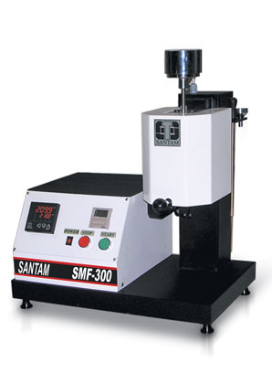 | 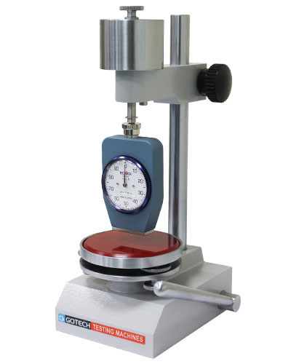
Cathodic Disbonding | Tensile+200° C Oven (Peeling-LapShear)
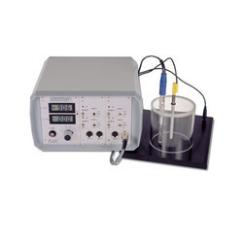 | 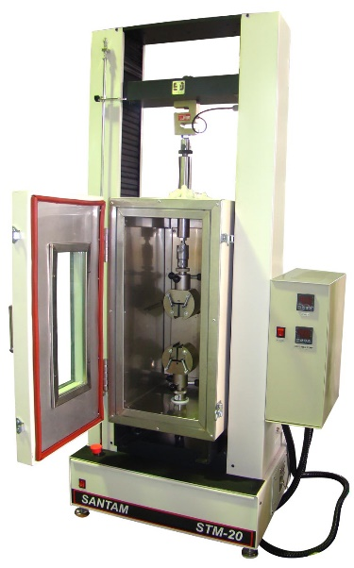
Vicat Softening Point | DSC
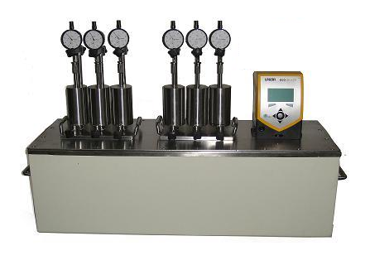 | 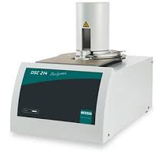
Optical Microscopy | -40°C Freezer
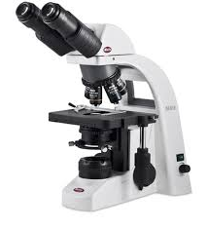 | 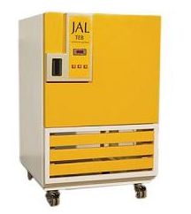
Softening point | Penetration
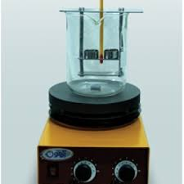 | 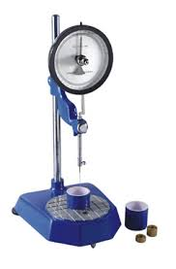
Particle Size Analysis
